**Christopher Meloni and Mariska Hargitay Just Reunited On the SVU Set: See the Pics! -** [Chris Meloni Posts Cute Pics w/ Mariska Hargitay on SVU Set | NBC Insider](https://www.nbc.com/nbc-insider/christopher-meloni-mariska-hargitay-svu-set-pictures-april-2023)

The last time Stabler and Benson linked up they almost hooked up, so Bensler fans are perched to learn more.

By [Jessica White](https://www.nbc.com/nbc-insider/authors/jessica-white)

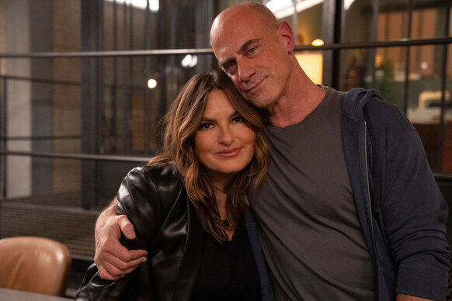

Photo: NBC

If you're a fan of [*Law & Order: Special Victims Unit*](https://www.nbc.com/law-and-order-special-victims-unit), the iconic partnership between Olivia Benson ([Mariska Hargitay](https://www.nbc.com/law-and-order-special-victims-unit/credits/character/captain-olivia-benson)) and Elliot Stabler ([Christopher Meloni](https://www.nbc.com/law-and-order-organized-crime/credits/character/det-elliot-stabler)) has probably contributed to that. Benson and Stabler's scenes are some of the best, and with Meloni headlining [*Law & Order: Organized Crime*](https://www.nbc.com/nbc-insider/franchise/law-order-organized-crime), fans have been soaking up any and all Bensler scenes they can get.

So fans will be happy to know that on April 7 Meloni [took to Instagram](https://www.instagram.com/p/CqtMYh8phAa/?igshid=YmMyMTA2M2Y%3D) to post a slideshow of BTS selfies with Hargitay on the set of *SVU*. In the first pic, Meloni, Hargitay, and seriesproducer Juan José Campanella cheese for the camera. In the second, [Meloni takes a pic of Hargitay](https://www.nbc.com/nbc-insider/law-order-organized-crime-did-stabler-just-admit-to-being-in-love-with-benson) getting a bit of a touch-up between takes.

Meloni captioned the IG post, "#Makingduntime on #svu with @therealmariskahargitay and @campanellajuanjose." Fans have been waiting for a Bensler reunion, and for a very valid reason!

Stabler's most recent appearance in [*SVU* was a seismic event](https://www.nbc.com/nbc-insider/stabler-just-tried-to-kiss-benson-on-law-order-svu) for fans rooting for Bensler to become a reality. In Episode 12 ("Blood Out"), Benson asked Stabler to pick up Noah, leading the [former partners to be in close quarters](https://www.nbc.com/nbc-insider/stabler-opens-up-about-benson-on-law-order-organized-crime) for the first time in a while.

After admitting he is compelled to protect her, Stabler finally opened up about his feelings for Benson, telling her he cares for her. The former partners shared an intimate embrace, and Stabler went in for a kiss, only to have Benson dodge the smooch at the very last second. [Cue millions of *SVU* fans](https://www.nbc.com/nbc-insider/law-order-svu-fans-react-to-benslers-almost-kiss) screaming at their television.

Benson told Stabler that she wasn't ready for a relationship with him, but it's clear that the chemistry between them is only heating up. [Their relationship](https://www.nbc.com/nbc-insider/benson-and-stabler-law-and-order-svu-moments) has passed a point of no return; after decades of tension, the cards are finally on the table. But before Benson can give Stabler the shot he deserves, there are some trust issues to navigate, and it won't be an easy task.

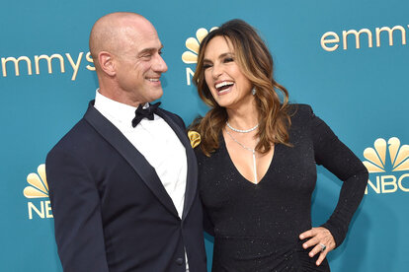

## [Mariska Hargitay Reveals the Moment She Knew Chris Meloni Would Play Stabler](https://www.nbc.com/nbc-insider/how-mariska-hargitay-chris-meloni-met-law-and-order-svu)

The duo haven't connected [since the steamy *SVU* scene](https://www.nbc.com/nbc-insider/ice-t-bensler-law-order-svu), so understandably, Bensler fans have been reeling. Where will they go from here? Is it going to be weird between them, or will their recent run-in only validate their feelings for each other?

Answers may finally come soon. Let's keep our fingers crossed!